**Subject :** Computer Networks

**Practical 6**

1. **Open Shortest Path First (OSPF) :**

The OSPF routing protocol has largely replaced the older Routing Information Protocol (RIP) in corporate networks. Using OSPF, a router that learns of a change to a routing table (when it is reconfigured by network staff, for example) or detects a change in the network immediately [multicasts](https://searchnetworking.techtarget.com/definition/multicast) the information to all other OSPF hosts in the network so they will all have the same routing table information. Unlike RIP, which requires routers to send the entire routing table to neighbors every 30 seconds, OSPF sends only the part that has changed and only when a change has taken place. When routes change -- sometimes due to equipment failure -- the time it takes OSPF routers to find a new path between endpoints with no loops (which is called "open") and that minimizes the length of the path is called the *convergence time*.

**Implement OSPF in Cisco Packet Tracer**

1. Create a Network in Cisco Packet Tracer

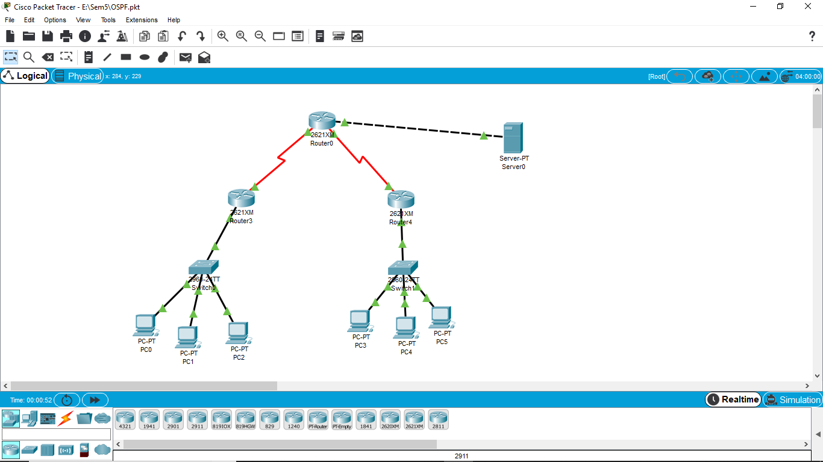

1. Give IP Configuration to all interfaces of all routers

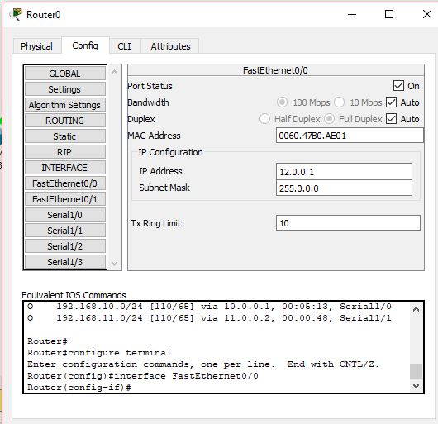

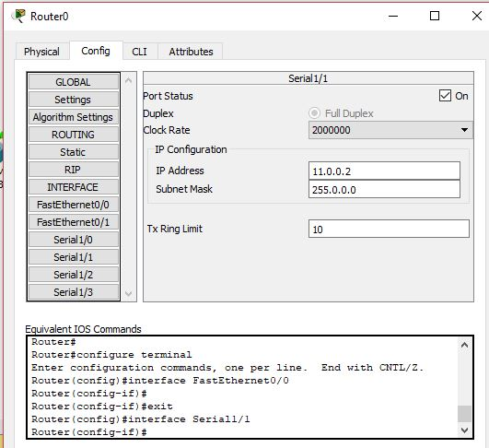

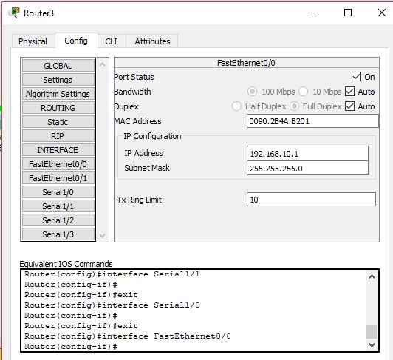

1. Make an entry in routing table in each router CLI for routing.
   1. Router ospf <ProcessID>
   2. Network <NID> <WildCard Mask> area <areaID>

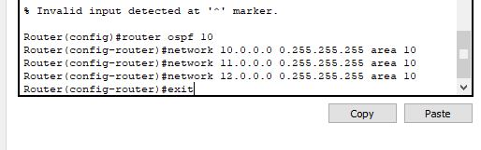

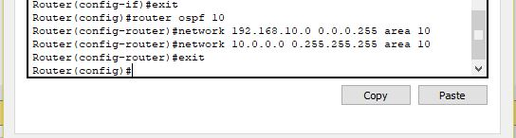

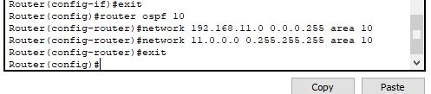

See all OSPF path in all router

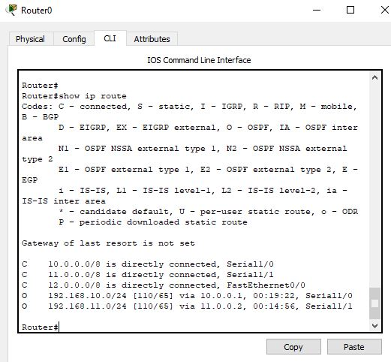

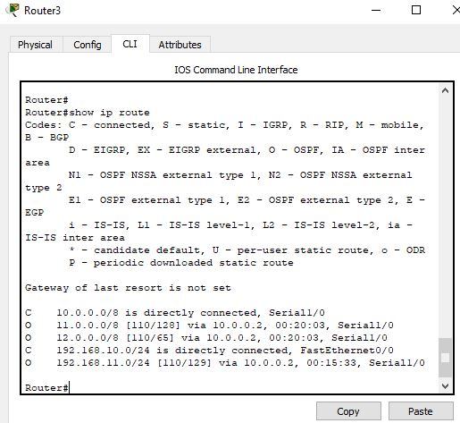

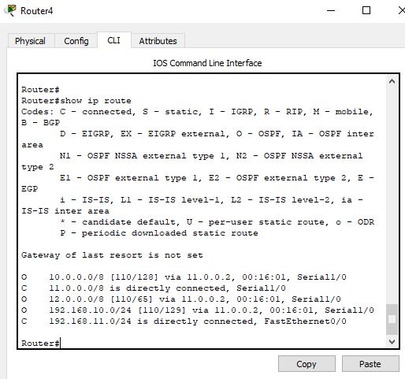

------------------------END